Gorilla™

How to remove unwanted data rows from metrics using Excel in 10 Steps:

In this example, we are working with questionnaire metrics, but we are not interested in any ‘quantised’ data metrics. Therefore, we want to remove all data rows which are of the form ‘questionkey-quantised’ from our questionnaire data metrics.
Here’s how to do this in 10 quick steps!

1. Open your Gorilla metrics file in excel:
It will look something like this:
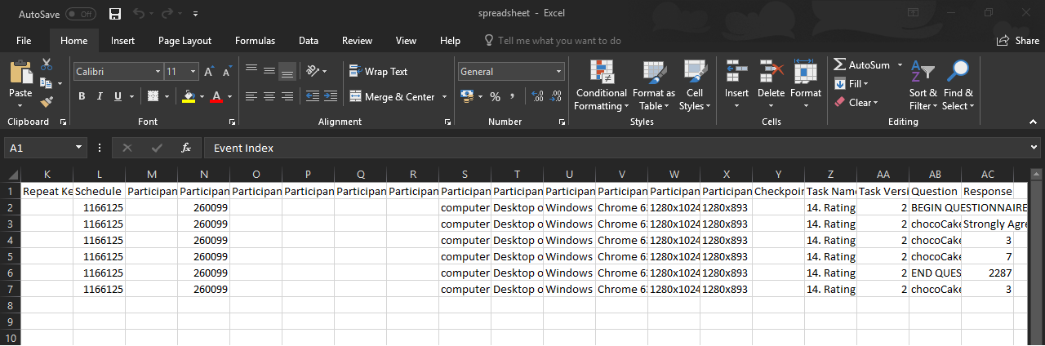

2. Navigate to the Data tab:
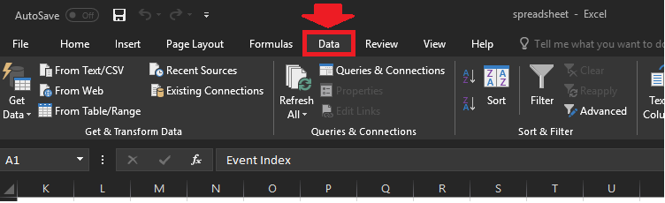

3. Click on the Filter Button:
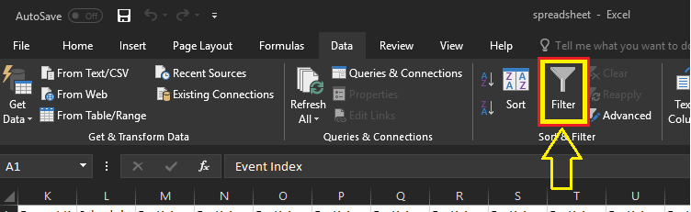

You will now see mini arrows (filter arrows) at the top of all your columns like this:
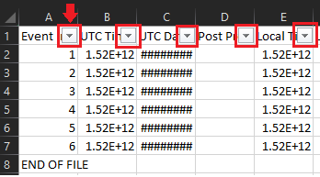

4. Navigate to the column which contains data you want to remove:
We want to remove all data with the form ‘questionkey-quantised’ so navigate to the column called ‘Question Key’
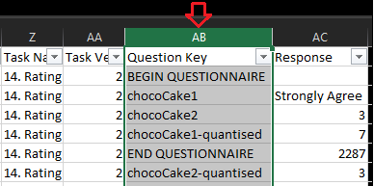

5. Click the filter arrow for the Question Key column:
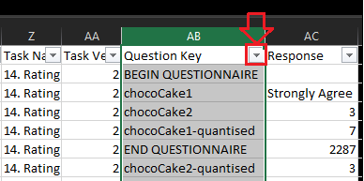
This will bring up a menu which looks something like this:
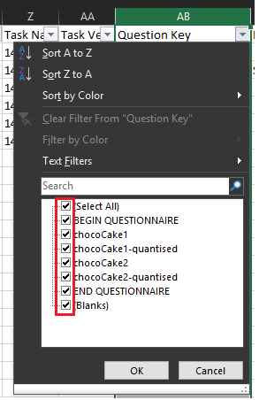
Notice all the ticks in the boxes? At the moment all our data is selected and is being displayed.

6. Check ‘(Select All)’ box (this will deselect all filters).
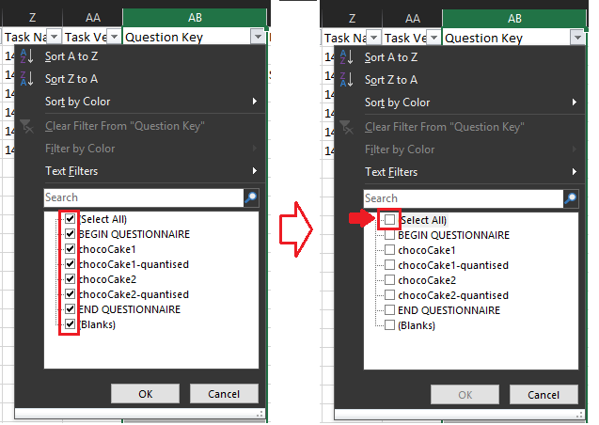
7.Next check only the data we want to remove and press ‘OK’. i.e. select every box that corresponds to a question key with the form ‘questionkey-quantised’.
Your filter box should now look something like this:
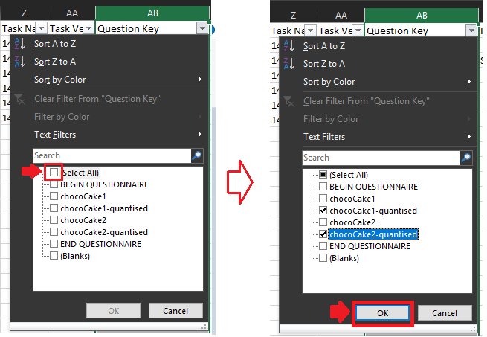
Your data spreadsheet will now look something like this:
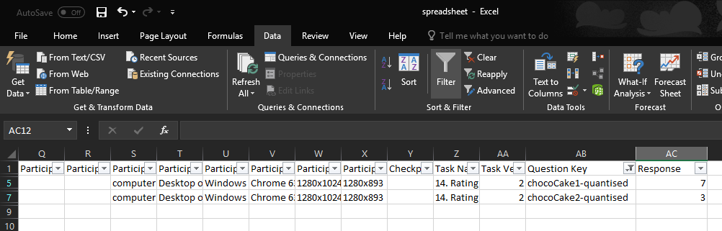
Notice how only the quantised data is being displayed on your spreadsheet.

8. Now highlight all the rows of data: Make sure you highlight the whole row by clicking on the row number itself.
Tip: To quickly select all rows - first click the top row of data then hold the SHIFT-key and press the last row of data – this will have selected all the rows between the two points.
Notice in this example there are only two rows, you will likely have more respondents and thus many more rows.

9. Now while keeping the rows selected Left-Click on the any of the row numbers and select Delete Rows from the menu.
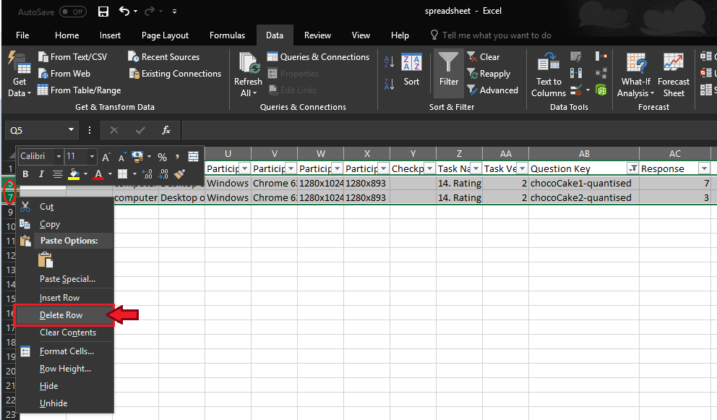
You should now be left with a seemingly blank looking data sheet:
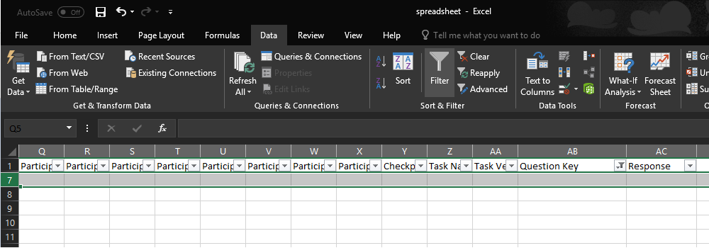

10. Finally remove all the filters and we have produced our cleaned questionnaire metrics!
Click again on the ‘Question Key’ filter arrow and check ‘(Select All)’ and press OK:
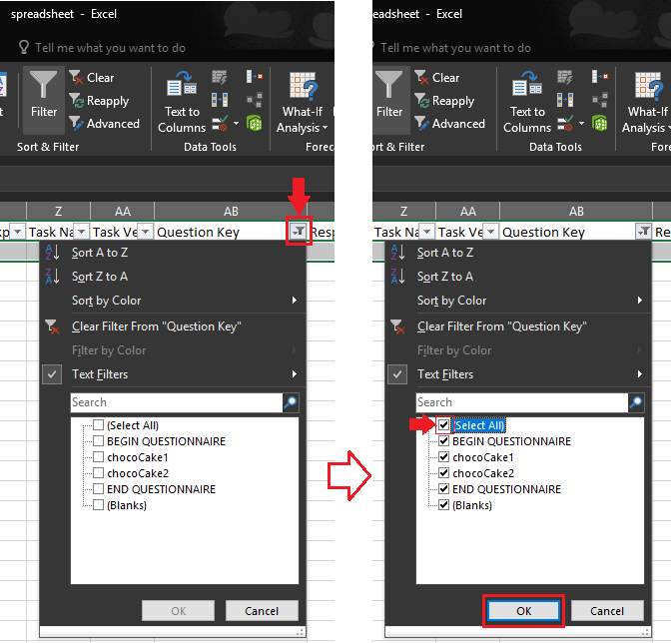

Your data sheet will now look like this:
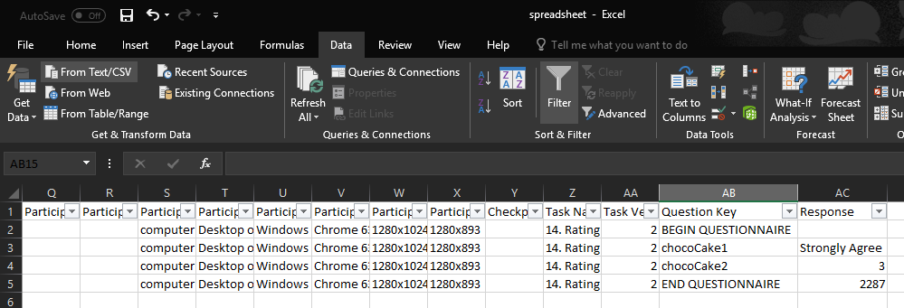
Notice how you data no longer contains any ‘questionkey-quantised’ data rows.

